Silverlight/Javascript Photo Gallery Viewer How-To

Written by Jeff Paries
http://www.designwithsilverlight.com

Not to be reproduced or redistributed without permission.
©2007

Introduction:
This tutorial describes how to add the Silverlight client-side photo gallery illustrated in figure 1 to a web site. The gallery is easy to install, and will configure itself to display up to 12 images, automatically hiding “empty” images. At this time, it is written to display images that are 640x480. For those interested in the technical details, there is a “How it Works” section after the Configuration section that goes into more detail.

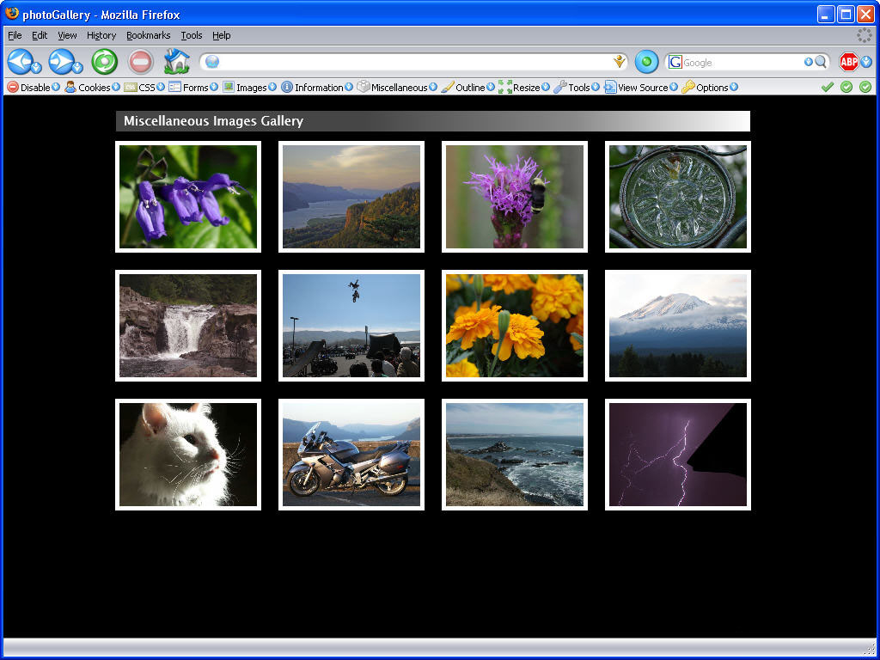
Figure 1

Configuration:
The gallery script looks for the folder called “images” to generate the photo gallery content.

If you would like to change the images being displayed in the gallery, you can do so by editing the gallery.js file. The one used for this example looks like this:

var galleryTitle = "Miscellaneous Images Gallery";

// set up an array for the images
var photoArray = new Array(12)
photoArray[0]="images/purpleFlowers640x480.jpg"
photoArray[1]="images/crownPoint640x480.jpg"
photoArray[2]="images/beeFlower640x480.jpg"
photoArray[3]="images/glassSun640x480.jpg"
photoArray[4]="images/smallFalls640x480.jpg"
photoArray[5]="images/motocross640x480.jpg"
photoArray[6]="images/marigolds640x480.jpg"
photoArray[7]="images/mtAdams640x480.jpg"
photoArray[8]="images/rosie640x480.jpg"
photoArray[9]="images/FJR1300640x480.jpg"
photoArray[10]="images/pacific640x480.jpg"
photoArray[11]="images/lightning640x480.jpg";

The galleryTitle variable contains the text string that is displayed in the title bar above the images.

The individual elements of photoArray point to the images contained within the “images” folder. To change the images being displayed, simply modify the filenames for the array elements. If you wish to display less than 12 images, simply change the appropriate array element(s) to null, like this:

photoArray[11]="";

Any elements that contain a null value will not be displayed in the gallery.

The preceding information describes the utilization of the gallery viewer. If you’re interested in how it works, the following section describes the scripts and XAML in more detail.

How it Works:
All of the functions described in this section are located in the page.xaml.js file.

The basic structure of the XAML file is shown in figure 3. The file contains a root canvas (“canvas1”), 12 “photo” canvases sized 170x130, each of which contains an image object that is 160x120. While not shown in the screen shot, there is also a rectangle for the background color of the title text, as well as a text block element to hold the text.

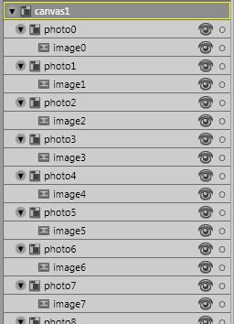
Figure 3

The difference in size between each photo canvas and its image creates a small white border around the image when the application is displayed over a background other than white. Notice that the photo canvases are all named sequentially, as are the images (photo0, photo1, etc. and image0, image1, etc. respectively). The sequential naming was an important aspect in generalizing the functions.

Upon initial load of the application, the “Loaded” event of the root canvas is used to call a function named loadImages. This event fires after the Silverlight content is loaded, but before the content is rendered. As such, the root canvas in the XAML file looks like this (the event function call is called out in red):

<Canvas
xmlns="http://schemas.microsoft.com/client/2007"
xmlns:x="http://schemas.microsoft.com/winfx/2006/xaml"
Width="775" Height="600"
x:Name="canvas1"
Loaded="loadImages">

The loadImages function starts by changing the text in the gallery title bar to whatever text is in the galleryTitle variable (set in the gallery.js file).

The initial state for each photo’s canvas in the XAML file is Visibility = Collapsed. As the function steps through each canvas in the XAML, Visibility is set to “Visible” if there is an image reference present for that position in the photoArray. This is what makes the application work with less than 12 images present – if an image reference is not present in the photoArray, no canvas will be drawn. It also allows the application to be used over any color background in the browser.

While I won’t go into the details of the storyboard creation here other than to say I used Blend, it is obvious when viewing the application that each photo has actions it can perform. When the mouse is moved over an image, it enlarges slightly. When the mouse is moved out, the image returns to normal size. When the mouse is over an image and the button is clicked, the photo is displayed full size, returning to normal size when the mouse is clicked again or moved off the image.

Each storyboard is named sequentially by action, with the number matching the canvas/image number. For example, the canvas named “photo3”, which contains “image3”, has storyboards called mouseEnter3, mouseLeave3, pictureZoomIn3, and pictureZoomOut3. This makes them easy to keep track of and access.

Interactivity is provided via the MouseEnter, MouseLeave, and MouseLeftButtonDown events, which are attached to each photo canvas in the XAML file, as shown here:

<Canvas MouseLeftButtonDown="pictureZoomIn" MouseEnter="mouseEnter" MouseLeave="mouseLeave" Width="170" Height="130" Background="#FFFFFFFF" RenderTransformOrigin="-0.003,-0.004" x:Name="photo0" Canvas.Left="10" Canvas.Top="45" Opacity="1" Visibility="Collapsed">
<Canvas.RenderTransform>
<TransformGroup>
<ScaleTransform ScaleX="1" ScaleY="1"/>
<SkewTransform AngleX="0" AngleY="0"/>
<RotateTransform Angle="0"/>
<TranslateTransform X="0" Y="0"/>
</TransformGroup>
</Canvas.RenderTransform>
<Image x:Name="image0" Width="160" Height="120" Canvas.Left="5" Canvas.Top="5" Stretch="Fill"/>
</Canvas>

The mouseEnter function, called when the mouse moves over an image, first goes through each visible photo canvas and sets the Z-Index to 0. This is necessary to keep images from opening behind other images.

The function then grabs the last two characters of the sender’s name. In this case, the sender will be one of the photo canvases (photo0, photo1, photo2, etc.).

The last two characters are used to account for images in the array above position 9. For example, when photo3 is the sender, photoPosition = sender.name.charAt(5) + sender.name.charAt(6); returns “3”+ “null” or 3. Photo11 would return “1” + “1” or “11”. Notice that the strings are being concatenated rather than being mathematically evaluated.

Once the photo number has been acquired, the function builds the name of the mouseEnter storyboard by adding the base storyboard name to the position:

nameString = "mouseEnter" + photoPosition;

Then the storyboard can be played:
sender.findName(nameString).begin();

The mouseLeave function uses the same technique for grabbing the last two characters to locate the appropriate item.

It then checks to see if the image has been clicked by checking the value of zoomFlag, which is changed when an image has been clicked (see the pictureZoomIn function description). This is an important nuance in controlling the animations, because if an image has been clicked and the mouse leaves the image, the action sequence is different than if the image is clicked a second time to scale it back down.

If an image has been expanded and is clicked a second time, the function will first zoom out to the slightly expanded mouse over size before then playing the mouse out action and resetting the zoomFlag for the next time the function is called. This gives the seamless effect of scaling the image all the way down to the original size, even though two actions are being played sequentially.

If the image has NOT been clicked, then the function simply plays the mouse out action.

The pictureZoomIn function, called when the mouse is clicked while hovering over an image, also uses the same technique of grabbing the last two characters for locating the appropriate item to act upon.

If the image clicked was already expanded, this function, like the mouseLeave function for an expanded image, will play the zoom out storyboard that takes the image from expanded back down to mouse over size. It then resets the zoomFlag for the next time the function is called.

If the image clicked has not been expanded, then the function sets the Z-Index to 1 so the image displays in front of all others, expands the image to full size, and sets the zoomFlag to 1.

